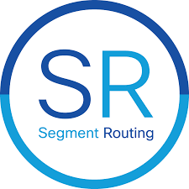

**The way of SR: Segment Routing**

**Md Abdullah Al Naser**

Datacom Enthusiast

**Blog 1**

Throughout history, people found different ways to talk to each other. People started with speaking to those close by, then figured out how to connect with people far away, even across countries, and even in space. But few people never stopped trying to improve how we communicate. Nowadays, our big goal is to make sure everyone can get online using the Internet, so we can access stuff anytime and anywhere. After many years of working on it by many dedicated enthusiasts, the Internet has become just as important as water and electricity for most people, but not everyone knows how it got so fancy.

Now, let's quickly look at some important Internet technologies and when they came into the big picture:

In 1969, we had ARPANET, which was like the Internet's ancestor.

In 1981, IPv4 was created.

In 1986, the Internet Engineering Task Force (IETF) was formed to make Internet standards.

In 1995, IPv6, a newer version of IPv4, became a standard.

In 1996, MPLS came into the picture.

In 2007, we got SDN.

In 2008, the OpenFlow protocol was born.

In 2013, we saw SR, including SR-MPLS and SRv6.

In 2014, VXLAN came into use.

The primary purpose of revisiting the aforementioned points is to get ready to talk about Segment Routing in some future blog posts. Stay tuned.

**Blog 2**

**IP-Based Forwarding: How It Works and Its Importance in Networking**

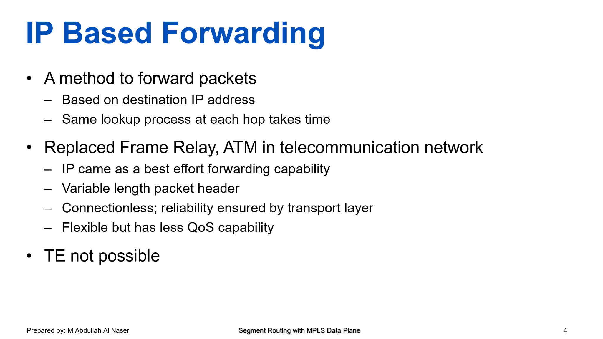

In the world of computer networks, there's a super important thing called "IP-Based Forwarding." It's a way to send data packets from one place to another using something called the "destination IP address." Let's take a closer look at what this means.

1. What is IP-Based Forwarding?

Imagine you want to send a message to your friend, and you know their home address. In the same way, IP-Based Forwarding uses the destination IP address of data packets to know where to send them.

2. How Does It Work?

When you send data from your computer to another, the network equipment, like routers, has to decide where to send it next. They use the destination IP address to figure this out. This is done at every hop along the way, and it can take some time because the same lookup process happens again and again.

3. Replacing Older Technologies

In the past, there were other methods like "Frame Relay" and "ATM" used for this purpose, but IP-Based Forwarding, often just called "IP," became the best way to do it. They were all used for different things and couldn't work together. ATM was good for high-quality connections and was used a lot in the beginning because it was reliable. IP, on the other hand, was more flexible and used in computer networks because it didn't require fixed packet sizes and relied on other protocols like TCP to ensure reliability.

ATM and IP networks were like a competition between telecom and computer networks. Telecom people wanted to use ATM to connect networks, while computer folks used it mainly for quality on IP networks without needing complex connections.

As time went on, computer networks became more advanced, focusing on fast, smart, and integrated services. But they didn't need the same level of quality as telecom networks, and their packets weren't all the same size. ATM's strengths, like fixed-sized packets and high quality, didn't fit well with computer networks. Also, ATM had some overhead that made it expensive for computer traffic.

In the end, as networks got bigger and had more services, ATM networks became too complicated and costly compared to IP networks. So, over time, ATM networks were replaced by IP networks.

4. Best Effort Forwarding

IP is known for being a "best effort" system. It tries its best to deliver data, but it doesn't promise that it will always work perfectly.

5. What Makes IP Special?

IP packets have variable length headers, which means they can carry different amounts of data. They're also connectionless, which means they don't have to stay connected from start to finish. Instead, the transport layer makes sure that your data arrives reliably.

6. Flexibility vs. Quality of Service

IP is quite flexible, which is great for sending different types of data. However, it's not so good at ensuring "Quality of Service" (QoS). This means it can't guarantee things like super fast speed or priority for certain data. This is why "TE," or traffic engineering, is not possible with IP.

In a nutshell, IP-Based Forwarding is a clever way to send data from one place to another based on the destination IP address. It's flexible and widely used, but it doesn't promise perfect quality. That's why it's essential to understand its capabilities and limitations when working with computer networks.

**Blog 3**

**MPLS: Simplifying Network Traffic Routing with Label-Based Approach**

In the world of networking, managing traffic efficiently is crucial to ensure the smooth flow of data from one point to another. One approach that simplifies this task is the label-based approach, a technique that uses labels in a fixed 32-bit header to make routing decisions. A 32-bit fixed label has been demonstrated (before hardware based forwarding came into the picture) to be more efficient than an IP packet with variable length.

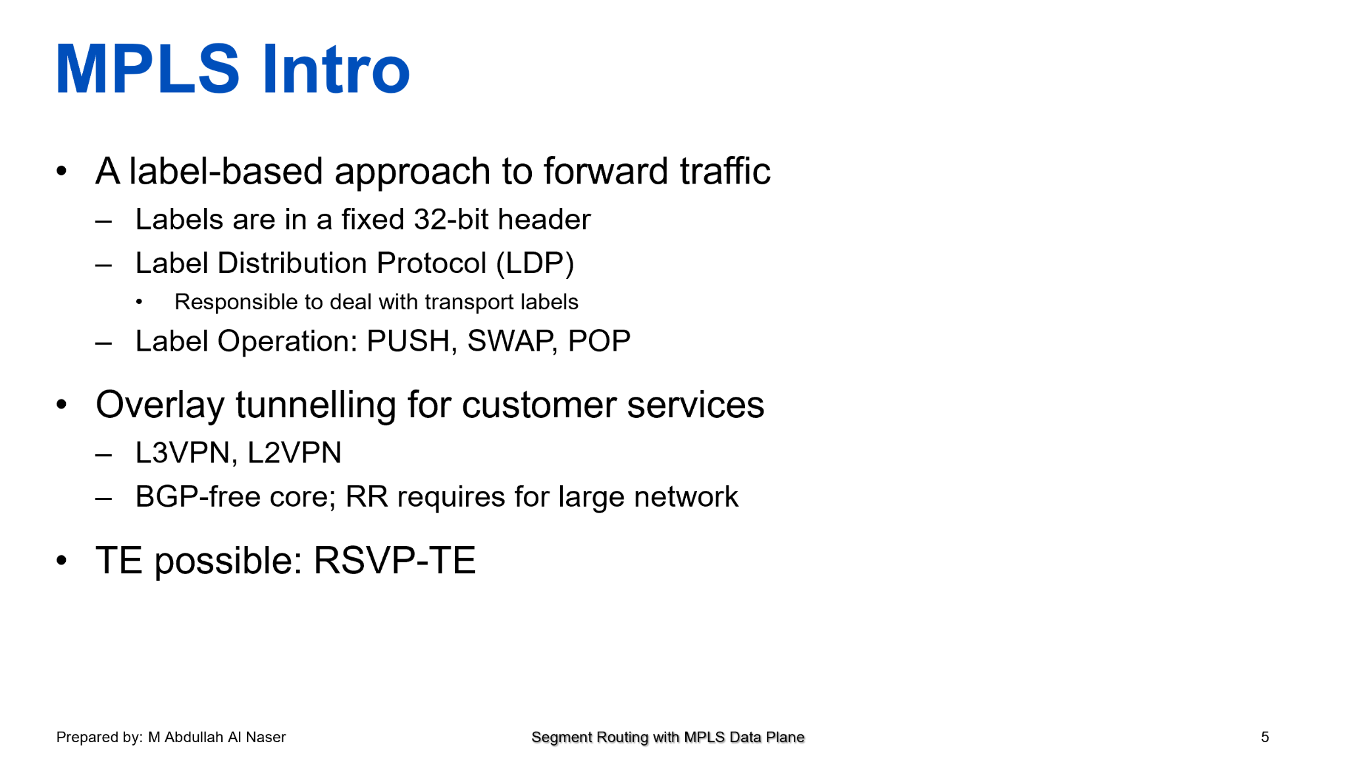

MPLS, which stands for Multiprotocol Label Switching, is a widely used networking technology that primarily operates in between the data link layer and network layer of the OSI model (popularly known as Layer 2.5). It was developed to improve the efficiency and flexibility of packet forwarding in IP networks, making it particularly useful for modern telecommunications and internet service providers.

1. Label-Based Approach

The label-based approach is a method used to guide network traffic in a more organized way. It uses labels, which are like tiny tags attached to data packets. These labels help routers understand where to send the data.

2. Label Distribution Protocol (LDP)

The Label Distribution Protocol (LDP) is a crucial part of the label-based approach. It's the protocol that routers use to generate label information locally and share with neighboring routers. This sharing of information ensures that every router in the network knows which label to use for a specific destination. LDP is typically responsible for dealing with transport labels.

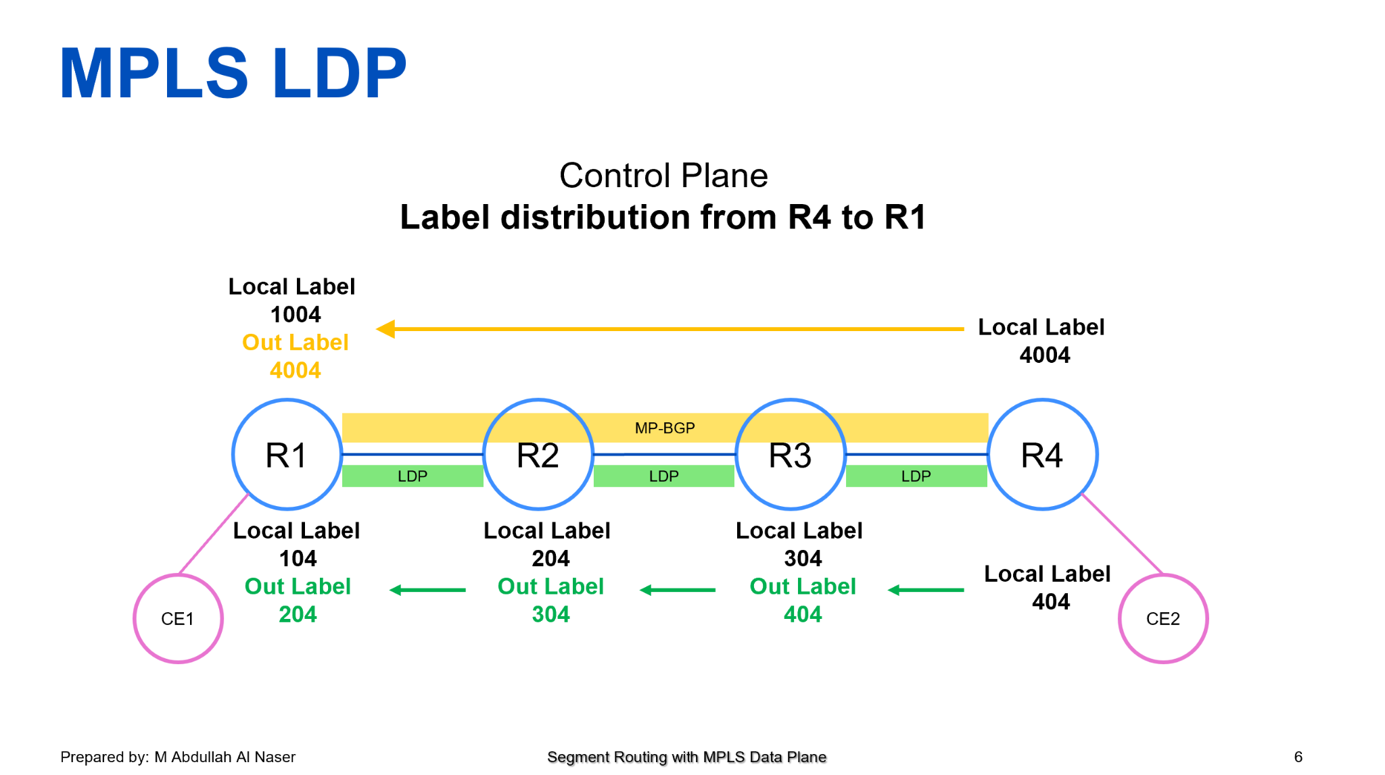

3. Label Operations: PUSH, SWAP, POP

In the label-based approach, routers can perform three main label operations:

PUSH: When a router (ingress PE) receives a native IP packet or ethernet frame from customer site A, it adds a label to that data packet, it's called "pushing" a label onto the packet. This label helps direct the packet to its destination (egress PE).

SWAP: Sometimes, a router (core router known as P) may need to change the label on a packet. This is called "swapping" labels.

POP: When a router (egress PE) removes the label from a packet, it's called "popping" the label. This is typically done when the packet has reached its final destination. At this point egress PE sends native IP packet/ethernet frame towards customer site B.

4. Overlay Tunneling for Customer Services

Overlay tunneling is a technique used to provide special services to customers over a network. It's like creating a private road on top of the regular highways. This allows to keep customers' routing information separate from each other and also allows controlled data transfer. Two popular overlay tunneling services are L3VPN and L2VPN.

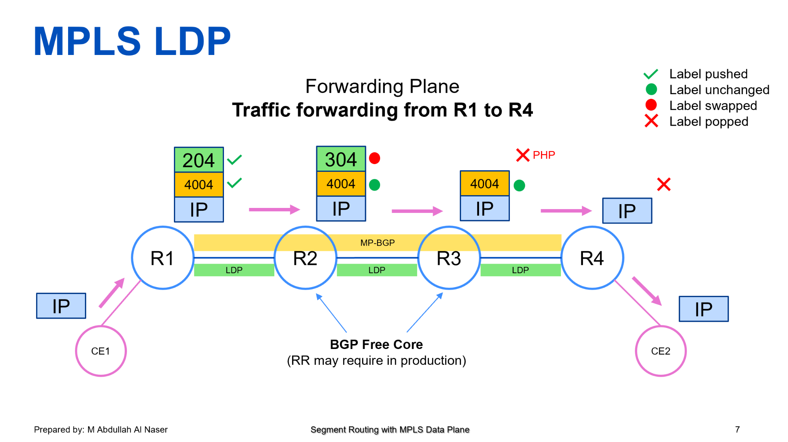

5. L3VPN and L2VPN

L3VPN and L2VPN are two types of Virtual Private Networks (VPNs) often used in the label-based approach:

L3VPN: This stands for Layer 3 Virtual Private Network. It's used for connecting different networks together, like joining branches of a company. It operates at the network layer and can handle both IP and non-IP traffic.

L2VPN: This is short for Layer 2 Virtual Private Network. It focuses on connecting individual devices, like computers or switches. It operates at the data link layer and is useful for specific applications.

6. BGP-Free Core; RR Required for Large Networks

In some networks, people aim to simplify things by having a BGP-free core. BGP (Border Gateway Protocol) is a complex routing protocol used on the internet. A BGP-free core means that the core of the network doesn't rely on BGP for routing. Instead, the core will perform a simple label swap operation which is more efficient than relying on looking up the routing table for each packet. However, in large networks, a special router called a Route Reflector (RR) may be required. The RR helps manage the exchange of routing information, it eliminates the need of complex full-mesh peering among PEs and makes the network more efficient.

7. TE Possible: RSVP-TE

TE, or Traffic Engineering, is about controlling how data flows on a network. RSVP-TE is a protocol that helps with traffic engineering by reserving network resources for specific data paths. This ensures that important data gets the priority it needs.

Just to sum up, the label-based approach simplifies network traffic management by using labels to guide data. It relies on the Label Distribution Protocol (LDP) and various label operations like PUSH, SWAP, and POP. Overlay tunneling, L3VPN, L2VPN, and BGP-free cores make it even more powerful. And for advanced traffic engineering, protocols like RSVP-TE come into play. Understanding these concepts can help make network routing more efficient and effective.

**Blog 4**

On the way…